**2014-2019**

**Technology**

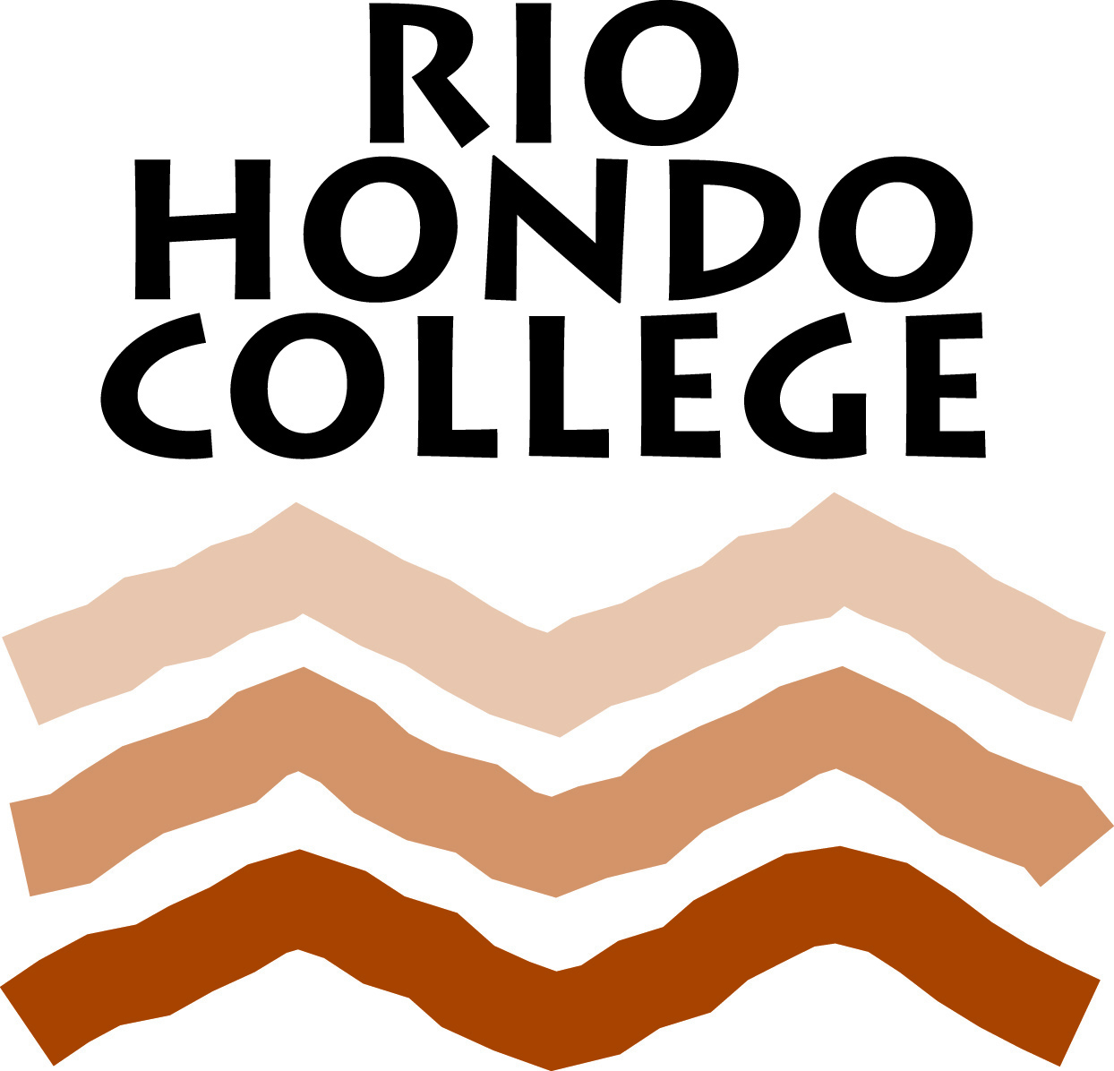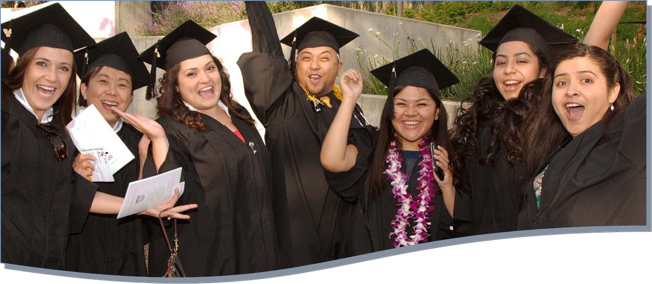**Master Plan**

**DRAFT – 06/12/2014**

DRAFT 5-30-14

Information Technology Planning Team

June 2, 2014

Created By:

Rio Hondo College College

4/21/2014

Created By:

Rio Hondo College College

4/21/2014

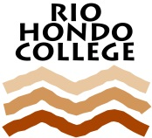

Rio Hondo College Mission Statement

**Vision Statement**

*Rio Hondo College strives to be an exemplary California community college, meeting the learning needs of its changing and growing population, and developing a state of the art campus to serve future generations.*

**Mission Statement**

*Rio Hondo College is committed to the success of its diverse students and communities by providing dynamic educational opportunities and resources that lead to associate degrees, certificates, transfer, career and technical pathways, basic skills proficiency, and lifelong learning.*

**Values Statement**

*As a teaching/learning community, we come together and strive to meet the needs, aspirations, and goals of our changing student population and communities. Since what we value forms the core of who and what we are, the College community – trustees, faculty, and staff – recognizes the importance of openly and candidly expressing the College’s values. Rio Hondo College values the following:*

**1. Quality Teaching and Learning**

*The College is dedicated to excellence in instruction and student services to develop the intellectual and personal competence of each student. Rio Hondo College is committed to preparing students to adapt to the demands of a multicultural society.*

**2. Student Access and Success**

*Rio Hondo College recognizes the individual worth and potential of every human being. Accordingly, the College offers an open access, comprehensive educational program to its students including basic skills, vocational education certificates and degrees, general education and transfer courses, and, for its community, economic development opportunities.*

*At Rio Hondo College, students will have an opportunity to develop ethical values, learn the rights and responsibilities of citizenship, develop career skills, and understand the scientific, artistic and social achievements of various cultures including their own.*

**3. Diversity and Equity**

*Rio Hondo College remains committed to the diversity of students, faculty, staff, and management. Diversity can be defined in many ways including ethnicity, gender, sexual orientation, socio-economic status, age, physical abilities, religious beliefs, learning styles, political beliefs, or other ideologies. Appreciation of diversity means the following:*

* *Recognizing that each individual is unique and understanding of individual differences.*
* *Recognizing the things that people have in common despite being members of diverse groups.*
* *Creating a safe, positive, and nurturing environment that cultivates respect for what these differences are.*
* *Moving beyond simple tolerance to embracing and celebrating the rich dimensions of diversity as a way of coming together as a community with a common purpose. The concepts of educational equity and student learning outcomes are central to the values of the College. Access to education and the opportunity for educational success for all students shall be provided, with particular efforts in regard to those who have been historically and currently underrepresented. Education should prepare students to adapt to the demands of a multicultural society.*

**4. Fiscal Responsibility**

*Rio Hondo College recognizes the importance of maintaining a fiscally sound, efficient, and effective college operation. It uses its resources – human, facilities, and financial – to the optimum benefit of its students, community, and staff.*

**5. Integrity and Civility**

*We value integrity, honesty, and respect in our actions and words.*

**Table of Contents**

Introduction 5

Historical Highlights 9

2015-2019 Technology Plan Projects - Overview 13

Student Success Initiative 14

Chancellor’s Office Initiatives 15

Audio Visual Standards 16

Infrastructure 17

Software/Applications 19

Acknowledgements 21

**Introduction**

# Introduction

Currently celebrating its 51st anniversary, Rio Hondo College serves approximately 28,000 students annually and provides a wide range of associate degrees, certificates, and lifelong learning opportunities.

Technology plays a key role in a student’s education from online registration to computers in classrooms to back-office systems that support student services. These systems are used extensively throughout the campus and online. As stated in its Institutional Goals and Objectives, one of the goals of the College is to “…meet the ever-changing technological needs required to support the educational process and to enhance student access and success. (Goal 9)” The technology plan outlined in this document is designed to augment and align with the College’s vision, mission, and values and form the basis for an open and visible technology roadmap to guide technology services for the next five years.

The ideas that form the basis of the Rio Hondo College Information Technology Master Plan are interwoven from a number of ongoing and specialized internal planning processes and two external initiatives. These planning processes, their interactions, and their relationship to technology are discussed next.

**Annual Planning Process**

Each year the College creates over one hundred program plans, thirty-one unit plans, and four area plans. Each of these plans contains a technology component, and some of the technology requests span multiple years. The “larger” technology requests that have emerged from the annual planning process have been considered for possible inclusion in the Information Technology Master Plan. Moreover, the annual planning process culminates in the College’s annual planning retreat. During the retreat technology issues are evaluated in the context of the College’s other goals and objectives. These ideas have been incorporated into both the Education Master Plan and, by extension, the Information Technology Master Plan.

**Information Technology Master Plan Process**

The development of Rio Hondo College College’s Technology Master Plan began Fall Term 2013. A workgroup was created under the auspices of the Superintendent/President with the goal of developing a technology plan for the College. The workgroup consisted of twenty-seven members of the College community able to represent the interests of students, faculty, and staff (see the Acknowledgments section).

Following the technology planning kickoff session, a series of meetings were conducted by members of the various workgroups, their staffs, and their representative bodies. Collectively, the Information Technology Planning taskforce generated over one hundred ideas related to technology improvements. The “core” ideas from this process have been incorporated into the Information Technology Master Plan.

**Educational Master Plan**

Rio Hondo College recently completed an update to its Educational Master Plan. While the focus of the Educational Master Plan is on the future direction of education at Rio Hondo College, there are a number of areas identified in the plan that require technology services for their implementation. These needs have been incorporated into the Information Technology Master Plan so that technologies necessary for the success of the Educational Master Plan are considered by the College.

**Facilities Master Plan**

At the same time the College has been updating its Educational Master Plan, it also updated its Facilities Master Plan. All new buildings and nearly every renovation to existing buildings contains a technology and equipment component. The updated Facilities Master Plan outlines a number of new or upgraded facilities projects, each of which requires networking and computer-related equipment. Consideration for these changes has been incorporated into the Information Technology Master Plan.

Together, the College’s various internal planning processes form a “planning pyramid” as illustrated below. The planning processes complement each other and are the foundation on which the Information Technology Master plans rests.

In addition to the College’s internal planning processes, there are two external initiatives that will necessitate technology changes/upgrades during the lifetime of this plan: the Student Success Initiative and the Chancellor’s Office 2013 technology initiatives.

**Student Success Initiative**

The Student Success Act of 2012 contains a number of sweeping changes that will impact community colleges throughout California. Included in the Student Success Initiative are changes to college reporting requirements that take effect in 2014. These changes are ongoing and will impact Rio Hondo College over the entire course of this plan. Additionally, enhancements to college systems are envisioned that make assessment, orientation, and education planning universal with the goal of improving success, retention, and completion. All of these enhancements rely on technologies that can be consistently applied across large numbers of students using a wide range of computing systems – desktop, laptop, and mobile device.

**Chancellor’s Office Initiatives**

In late 2013, the Chancellor’s Office awarded five year grants to three California community colleges to create and manage the technology necessary to support these initiatives: the Common Assessment Initiative, the Online Education Initiative, and the Education Planning Initiative. The goals of each initiative are briefly outlined below.

**Common Assessment Initiativ**e – Develop a common electronic assessment tool for use across the California Community College system. Create a consistent set of standards for multiple measures to be used for student assessment.

**Online Education Initiative –** Increase the number of Associate Degrees for Transfer (ADT) by increasing the number of online course offerings available to students. Improve online retention and success.

**Education Planning Initiative** – Provide a low cost/no cost solution to those colleges without an Education Planning and Degree Audit system. Provide transcript, articulation, and curriculum inventory elements to colleges with existing Education Planning and Degree Audit Systems.

All three initiatives have the potential to impact Rio Hondo College computer systems and operations during the timeline of this plan. Exactly what form these changes will take is hard to discern at this time. All three initiatives are in their formative stages, and the rollout of the products and services of each initiative is still being defined, but it is almost certain these initiatives will impact the College. Rio Hondo College has been accepted as one of the “pilot” schools for the Common Assessment Initiative, so the College will have an insider’s view – and opportunity to contribute ideas – to this initiative.

The expectation is that Rio Hondo College will need to develop electronic interfaces to the computer systems hosting the initiatives, but the form and frequency of these interfaces is unknown at this time. The effort required to complete these interfaces is also unknown as of this writing.

**Summary**

As outlined above, the Rio Hondo College Information Technology Master Plan is based on the varied and wide ranging planning processes employed by the College. While the primary focus of the Information Technology Master Plan is on the future, the College has undergone a technology transformation since the last complete master plan was created in 2007. It is worthwhile highlighting some of the College’s achievements in the intervening time.

**Historical Highlights**

# Historical Highlights

Since the creation of the last Information Technology plan in 2007 and its update in 2010, Rio Hondo College has made numerous upgrades to its technology systems. There have been upgrades in its governance procedures, its software systems, and its hardware infrastructure. This section recognizes a number of these enhancements.

**Governance**

Rio Hondo College made enhancements to its IT governance structure to improve the process used to evaluate and manage the College’s information systems and technologies. The goal of these changes is to expand the range of stakeholder participation regarding the technology directions of the College and ensure broad support for the systems used at Rio Hondo College.

**Equipment and Technology Committee**

The Technology Committee is a sub-committee of the Planning and Fiscal Council and meets once per quarter from September through May, or as needed. The Technology Committee is the primary technology governing body of Rio Hondo College, and its membership is made up of the College’s vice presidents, five faculty representatives, and three classified representatives appointed by CSEA. Its charge is as follows:

*The Technology Committee has overall information technology governance responsibility at the Rio Hondo College Community College District with the purpose of furthering the institution’s strategic priorities. Included in this mission are evaluating, prioritizing, and approving technology initiatives that assist the student, faculty, staff, and administrators of the Rio Hondo College Community College District in achieving educational excellence. The Technology Committee is a subcommittee of the Planning and Fiscal Council.*

**Distance Education Committee**

The Distance Education Committee is responsible for developing and recommending quality standards for online education, developing best practices to ensure regular and effective contact for distance education, and making recommendations to maintain compliance with the Americans with Disabilities Act (ADA) in the College’s online courses. Additionally, the Distance Education Committee recommends training standards for faculty teaching online and provides input on technical issues related to teaching online. The committee is composed of two administrators, twelve faculty members, two classified representatives, and Rio Hondo College’s Information Systems Director. The committee meets once per month from September-May.

**Enterprise Systems Advisory Committee**

The Enterprise Systems Advisory Committee is a sub-committee of the Technology Committee and meets once per month from September through May. This committee has responsibility for evaluating and assisting with the prioritization of projects related to the College’s “core” enterprise systems. Examples include the Banner Student system and the Blackboard Learning Management system. This committee is also involved in consideration of new enterprise software. Its charter is as follows:

*The Enterprise Systems Advisory Committee (ESAC) addresses the broader ongoing issues of administrative systems and the deployment of information technology to meet the operational needs of the Rio Hondo College Community College District. The Chair will be the IT Director and the co-chair will be a faculty member elected from and by the membership for a one year term. The ESAC is a subcommittee of the Technology Committee.*

**Instructional Technology Committee**

The Instructional Technology Committee is a sub-committee of the Academic Senate and meets once per month from September through May. The Instructional Technology Committee reviews and makes recommendations to the Academic Senate on matters relating to technology use in teaching and student services. This includes assessment of both software and hardware resources available for classrooms and online. The committee is composed of elven faculty members, two administrators, two classified representatives, and the Director of Information Technology.

**Software System Upgrades**

Since the College’s last full information technology planning cycle, the College has completed numerous upgrades to many of its “core” enterprise systems. What follows is an outline of the major improvements that have occurred.

**Banner Student System Implementation**

In 2009 Rio Hondo College successfully converted to SunGard Higher Education’s Banner Human Resources and Student system. This upgrade replaced a legacy system that had been used at Rio Hondo College since 1984. This substantial upgrade in system’s capability provides improved features and functions to the College’s students, faculty, and staff.

**Conversion to CCCApply**

As part of the Banner project, the College moved its application process to CCCApply and standardized its registration process. This change brought Rio Hondo College into conformity with the majority of California community colleges, most of which use CCCApply for application processing. In 2013 the College migrated again to OpenCCCApply, the Chancellor’s Office newly created online application system.

**Electronic Financial Aid Disbursement**

In 2010, as part of the continued Banner implementation, Rio Hondo College performed its first Financial Aid disbursement. The College has teamed with Higher One to create a paperless financial aid disbursement process. This improves the speed with which students receive their funds and provides other internal efficiencies to the College.

**AccessRIO Portal**

The AccessRIO portal, introduced in March of 2011, gives students, faculty, and staff access to many of Rio Hondo College’s systems through one system login. Through AccessRIO students gain access to Blackboard, student email, library resources, and student accounts and financial aid information. Additionally, students can search, register, and pay for classes. Faculty use AccessRIO to manage their classes – including grading and dropping students – access Blackboard, manage their email, and enter information on Student Learning Objectives. Nearly all of Rio Hondo College’s web-based systems and support services are available through AccessRIO.

**Blackboard Connect Emergency Contact System**

In the fall of 2010, the College implemented the Blackboard Connect Emergency Contact system. This system provides voice, email, text, and combinations thereof to students, faculty, and staff in the event of a campus emergency. The system was first tested during the Fall Term of 2010 and was used to send nearly 27,000 notifications. The system is tested at least once each term as part of the College’s emergency drills.

**Lumens “Fee-Based” Registration System**

In July, 2011 the College converted its fee-based, community service registration process from what was a nearly manual process to the web-based system, Lumens. Lumens is an online service that allows students to search, register, and pay for classes via the Internet. It also provides services to faculty, such as rosters and other classroom support tools, as well as accounting tools and management reports.

**DegreeWorks**

Rio Hondo College introduced the DegreeWorks degree audit system to its counselors and students in 2011. This system assists students and their counselors with creating electronic education plans and performing “what if” scenarios for students examining their educational options. It also provides valuable management information that can be used for planning course offerings in future terms.

**Infrastructure**

The College makes ongoing upgrades to its technology infrastructure to replace aging equipment and acquire the tools necessary to support the technological advancement of the College. Discussed below are some of the major infrastructure improvements completed in the past several years.

**Desktop Technology Computer Refresh**

In 2011, approximately 400 computers were replaced as part of a program to trickle down or retire aging equipment. The remaining machines were upgraded to Windows 7 and Office 2010.

**Cisco Phone VoIP Implementation**

The College completed the rollout of its Voice over Internet Protocol (VoIP) phone system replacement. The College has retired its analog phone system as a result of this upgrade.

**Core Router Upgrade**

In 2009 the College upgraded its core network infrastructure creating a redundant network backbone spread between multiple facilities on campus. This upgrade also increased the speed of the network backbone to 10 gigabits per second (10GBPS). This project gives Rio Hondo College sufficient network bandwidth to support any technological upgrades in its current technology plans.

**Server Virtualization Project**

Ninety percent of Rio Hondo College’s data center servers have been “virtualized.” This project has reduced electrical requirements in the data center. It has also improved manageability and recovery in the event of natural or man-made disaster.

**Admissions and Records Imaging Project**

Over 900,000 Admissions and Records documents were scanned and indexed and loaded into the Banner Student system. This project has eased the retrieval of “paper” records associated with students’ accounts.

**2014-2019 Technology Plan Projects**

# 2015-2019 Technology Plan Projects - Overview

In the sections that follow the primary projects of the Information Technology Master Plan are identified and explained. This page provides a brief summary of these activities.

**Student Success Initiative**

*Provide technological support to assist in achieving the goals of the Student Success Initiative*

* Reporting – Mandatory reporting is a requirement of the Student Success Initiative.
* Early Alert – Identify students during a term who could benefit from additional support services.
* Online Orientation – Integrate the new online orientation system into the College’s student system.
* Needs Based Scheduling – Improve scheduling by intelligently identifying students who need particular courses.
* Graduate Identification – Use the College’s data systems to identify potential graduates.
* Ongoing Data Analysis – Support the Student Success Initiative through ongoing data analysis.

**Chancellor’s Office Initiatives**

*Develop technology solutions to integrate Rio Hondo College’s systems with the Common Assessment, Online Education, and Education Plan initiatives*

* Incorporate the Common Assessment, Online Education, and Education Plan systems into Rio Hondo College’s technology portfolio as warranted or required.

**Audio Visual Standards**

*Ensure classroom technology meets the needs of students and faculty*

* As part of the College’s facilities improvements, upgrade audio visual systems to the campus standard.

**Infrastructure**

*Provide a secure and reliable environment to support students, faculty, and staff*

* New Facilities or Facilities Upgrades – Support the new or improved campus facilities.
  + New Facilities
    - Arts Complex and Pico Rivera Education Center
  + Remodels or Retrofits
    - Administration Building / “L” Tower retrofit / Science Building (Nursing remodel) / Business Building remodel
* Disaster Recovery Plan – Develop a disaster recovery plan to secure the College’s technology assets in a catastrophic event.
* Banner Hardware Replacement – Replace the aging Banner system hardware.
* Virtual Desktop – Explore the option of replacing computer lab desktop machines with “virtual” desktops.
* Technology Refresh – Develop a mechanism for replacing aging hardware on a scheduled basis.
* Wireless Upgrade – Support the ever increasing demands for wireless services.

**Software/Applications**

*Develop technology solutions to maintain currency, improve efficiency, and enhance service*

* Banner Migration and Upgrades – Migrate the Banner student system to new hardware and maintain Banner and its supporting systems at appropriate release levels.
* Mobile Applications for Banner – Implement the Banner mobile device tools.
* Cloud Migration – Examine the option to move various Rio Hondo College systems to “cloud” service providers – email, data storage, telephony.
* Imaging Projects – Explore imaging solutions to reduce paper in select departments.

# Student Success Initiative

**Objective**

*Provide technological support to assist in achieving the goals of the Student Success Initiative.*

**Reporting**

The Student Success Initiative (SSI) demands additional reporting to the Chancellor’s Office to track progress against the objectives of the SSI. Various funding sources to support implementation of the SSI are tied to the information provided in the SSI’s mandatory reporting requirements. The first set of SSI reports are due following the Summer 2014 Term and continue each term thereafter.

**Other SSI System Enhancements**

**Early Alert**

The College is in the process of resurrecting its Early Alert program to identify students who may need additional assistance with their classwork while a term is still in progress. The goal of this program is to improve success and retention through proactive intervention. Technology is used in this program to identify and contact the target population.

**Online Orientation**

Rio Hondo College is in the final stages of developing its online orientation system. To be successful, the online orientation must be seamlessly integrated into Rio Hondo College’s systems to lead people to the orientation and then collect outcome information for reporting to the Chancellor’s Office.

**Needs Based Scheduling**

As a larger percentage of the Rio Hondo College student population create education plans in the next several years, it is possible to use this information to improve the College’s scheduling process. A “critical mass” of education plans can be used to more intelligently determine course offerings. For example, if one knows from the education plan database that next term one thousand students need course X, then provisions can be made to satisfy this requirement. The goal of this project is to align course needs with course offerings to promote timely degree and certificate completion.

**Graduate Identification**

Develop a mechanism to identify students who may be eligible for a graduation or transfer degree or certificate of which they are unaware. The objective is to maximize the student’s educational investment and ensure the student “gets everything he or she deserves.” A second objective of this project is to increase the number of degrees and certificates awarded by Rio Hondo College.

**Ongoing Data Analysis**

The Student Success Initiative is highly data driven. It is anticipated there will be evolving data analysis requirements as the Student Success Initiative unfolds in the next several years.

# Chancellor’s Office Initiatives

**Objective**

*Develop technology solutions to integrate Rio Hondo College’s systems with the Common Assessment, Online Education, and Education Plan initiatives.*

As explained in the Introduction, in 2013 the Chancellor’s Office released three well-funded five year grants to develop a common assessment tool, promote and improve online education, and assist colleges with education plan development. All three initiatives are in their formative stages, and Rio Hondo College is participating in the Common assessment program as a pilot college. It is unclear at this time how these initiatives will impact Rio Hondo College technologically, but if history is a guide, one can assume community colleges throughout the state will be “encouraged” or mandated to participate in these initiatives as they unfold. For example, it is conceivable that within several years, the most widely accepted assessment tool for incoming students will be the tool developed/recommended by the Common Assessment Initiative. This, of course, will require integration into Rio Hondo College’s systems. One can envision a similar pattern unfolding with the other two initiatives; therefore, it is and will be important to stay informed about the activities of these initiatives.

# 

# Audio Visual Standards

**Objectives**

*Ensure classroom technology meets the needs of students and faculty.*

**Audio/Visual Standard**

The College has developed a series of standards for classroom audio/visual equipment. These standards have been implemented in all of the College’s new buildings and education centers. As additional facilities are built or remodeled, audio visual systems will be brought in line with the College standards.

# Infrastructure

**Objectives**

*Provide a secure and reliable environment to support students, faculty, and staff.*

**New Facilities and Building Upgrades**

New facilities invariably demand new network equipment, computers, printers, and audio/visual equipment. In most cases building remodels require similar upgrades as the building is torn apart and rebuilt. The Facilities Master Plan outlines a number of possible new and upgraded facilities. In all of these situations new network, computing, and audio/visual equipment will need to be procured, configured, and installed. The list of potential new facilities and remodeled facilities is outlined below.

**New Facilities**

* Arts Center Complex
* Pico Rivera Education Center

**Building Upgrades**

* Administration Building Remodel
* “L” Tower Remodel
* Science Building (Nursing Remodel)
* Business Building Remodel

**Disaster Recovery Plan**

While Rio Hondo College currently performs daily offsite backups – a precursor to any disaster recovery scenario – the College currently does not have a mechanism for reconstituting its hardware and network infrastructure following an extreme event such as an earthquake or fire. This project would examine the College’s data and technical systems and establish a hierarchy for how long the College could operate without particular systems. This hierarchy would then be used to create a strategy for bringing those systems back online in the allotted timeframe. A “disaster recovery” service provider will be sought to assist with implementation of the plan.

**Banner Hardware replacement**

The current Banner hardware was purchased in 2007 and is reaching end of life. This project would replace the existing hardware with updated equipment.

**Ongoing Network Equipment Replacement**

The College has developed a replacement schedule for its network equipment – routers, switches, servers, batteries, etc. – based on the age of the equipment and its expected service life. During the timeline of this plan, equipment will be replaced according to this inventory schedule.

**Computer Lab Virtualization**

In the past five-seven years the College has “virtualized” its server infrastructure. “Virtualization” is a technology that allows more than one operating system to run on a given piece of hardware. Rio Hondo College’s 130 servers are currently running on ten physical machines. Virtualization reduces environmental demands for space, electricity, and cooling and eases the management burden of large server farms. It also offers beneficial financial returns. This project explores the opportunities of extending virtualization to the desktop to accrue similar benefits.

**Technology / Device Refresh**

Computer equipment, printers, audio visual systems, software age at different rates but all need to be upgraded or replaced on a scheduled basis. The College has created an equipment inventory to assist in the replacement or upgrade of its computing infrastructure.

**Wireless Upgrade**

Wireless usage continues to experience rapid growth on the Rio Hondo College campus as a result of the increasing use of mobile devices – smartphones, tablets, and laptops. It is important to maintain and upgrade the College’s wireless infrastructure as needed to provide adequate coverage and service to Rio Hondo College’s students, faculty, and staff.

# Software/Applications

**Objectives**

*Develop technology solutions to maintain currency, improve efficiency, and enhance service.*

**Banner Migration and Upgrades**

During the next five years there are a number of substantial projects that must be undertaken to maintain the Banner Student and Human Resources system.

* **Data Migration to New Hardware**

The upgrade of the Banner hardware, as outlined in the Infrastructure section, also requires that the Banner software suite be installed and configured on the new hardware and the data migrated to the new system. These two projects need to be performed in tandem.

* **Luminis 5.0**

The AccessRio portal is implemented using a software system called Luminis. The College is currently using version 4.5 of this product, but version 4.5 will reach end of life in the next couple years, and the College will need to upgrade to version 5.0.

* **Oracle Database Upgrade**

The database used by the Banner Student system will need to be upgraded to the newest version during the timeline of this plan.

**Mobile Applications for Banner**

Ellucian, the company that developed and maintains the Banner Student system, has developed a number of mobile applications that allow students to register, pay, and track various aspects of their education on their mobile devices. As students increasingly demand increased application support on mobile technologies, providing this service to students is critical.

**Cloud Migration**

The option of using “cloud” service providers for various applications that have historically been hosted on Rio Hondo College servers is increasingly attractive from both a financial and a service standpoint. Systems that warrant this consideration include email, data storage, and telephony.

**Imaging Projects**

In 2013 the College completed a project to digitally scan and index over 900,000 admissions and records documents. The purpose of this project was to improve efficiency when retrieving old records and insure critical documents are stored electronically offsite. There are a number of other departments at Rio Hondo College with similar record stores that would benefit from this process.

**Acknowledgements**

# Acknowledgements

This plan is the result of the effort of many people in the Rio Hondo College community – faculty, administrators, and staff. The contributors to this plan provided their insights about technology usage at Rio Hondo College and their thoughts and ideas for advancing the use of technology for the College community.

Important participation in this process was provided by the following individuals:

**Rio Hondo College Administration, Faculty, and Staff**

Superintendent/President

Vice President – Academic Affairs

Dean of Arts and Cultural Programs

Dean of Behavioral and Social Sciences

Dean of Business

Dean of Career Technical Education

Dean of Communications and Languages

Dean of Health Science and Nursing

Dean of Kinesiology, Dance, and Athletics

Dean of Library

Dean of Mathematics and Science

Dean of Public Safety

Vice President – Student Services

Director of Admissions & Records

Dean of Counseling Services

Director of EOPS/DSPS

Director of Financial Aid

Interim Vice President of Finance & Business

Director of Facilities

Faculty Senate President and Faculty Representatives (4)

CSEA President and Representatives (4)

Director of Marketing

Dean of Institutional Research and Planning

Distance Education Committee Chairperson

Director of Information Technology Services