RHC Approval Process for CTE Programs
Prepared August 14, 2019

This overview has been prepared to initiate a review of available labor market data and a general discussion of the committee’s approach to the review of CTE curricula.

At the final in-person meeting of the RHC Curriculum Committee of the 2019-2020 academic year (May 8, 2019), there was a brief discussion about the review process for noncredit CTE programs. The elements codified in the committee’s minutes can be found later in this document.

In light of the process of “streamlining” that has granted greater responsibilities with respect to curriculum review to the local level, it is now proposed that our local process for review of ALL CTE curriculum be re-visited to ensure that our CTE programs are truly serving our students. Below are relevant excerpts from the 2017 document titled “Streamlining Curriculum Processes in the California Community College System” that made the case for increasing local curriculum approval authority.

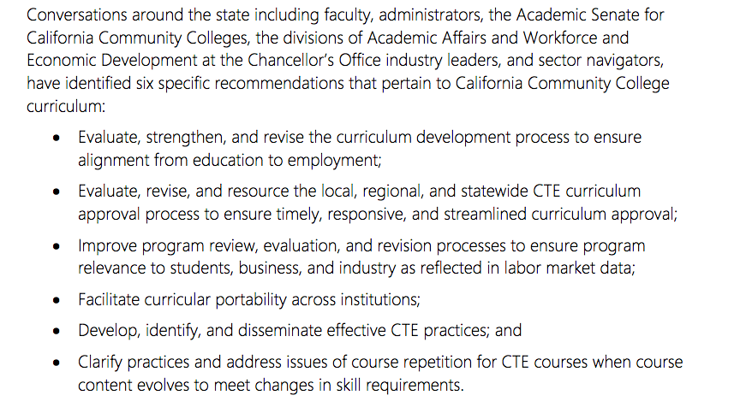

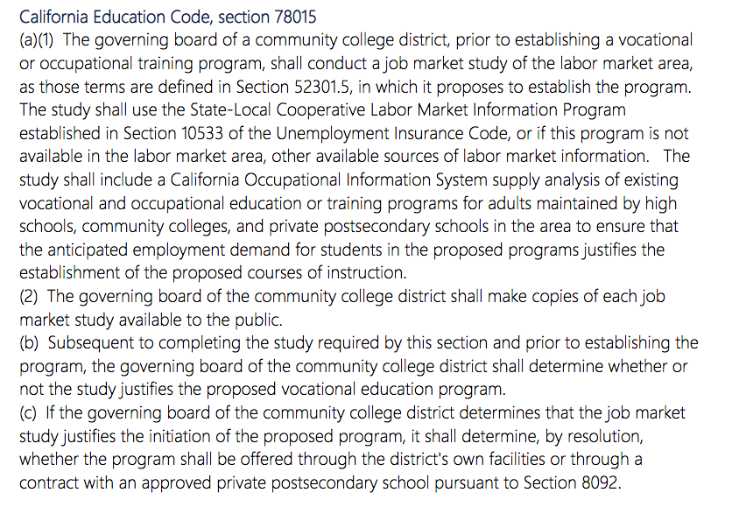

May 8, 2019 Minutes

- Criteria for noncredit courses - Per the PCAH:

Michelle Pilati asked the committee members to review the criteria for noncredit courses. (See below) Her goal is for the committee to establish guidelines for new noncredit CTE courses that lead to jobs. She explained that CTE programs need LAOCRC approval on the credit side and that we need to establish a clear process for CTE noncredit courses as well. She asked the committee to think about how this would work and bring back ideas in Fall.

Noncredit curriculum is defined in title 5, section 55002(c): “A noncredit course is a course which, at a minimum, is recommended by the college and/or district curriculum committee (the committee described and established under subdivision (a) (1) of this section) and approved by the district governing board as a course meeting the needs of enrolled students.”

For college preparation noncredit curriculum, need is presumed to exist if:
- there is a student demand for a program or course AND
- its transition to credit work has been documented.

For both credit and noncredit Career Technical Education (CTE) programs, or those that respond to economic development interests, need for the program must be documented by:
- supplying current labor market information (LMI) within the local service area of the individual college
- and/or a recent employer survey as per Education Code 78015.
- In addition, a current job market analysis, or other comparable information, must show that jobs are available for program completers within the local service area of the individual college
- and/or that job enhancement or promotion justifies the proposed curriculum.

However, if cooperative planning with neighboring colleges has occurred, labor market evidence for the region as a whole may be sufficient. Statewide or national labor market evidence may be included as supplementary support, but evidence of need in the specific college service area or region is also necessary. If the college believes the program has statewide or national importance and wishes to substitute statewide or national labor market evidence for local evidence, an explicit justification of why this is appropriate must be included.

Two noncredit CTE categories:

1. Short-term Vocational Programs are designed for high employment potential that lead to a career-technical objective, or a certificate or award directly related to employment. Short-term vocational programs should be designed to: improve employability; provide job placement opportunities; or prepare students for college-level coursework or transfer to a four-year degree program. They shall also be mission appropriate (Ed. Code § 66010.4(a)(1)), meet a documented labor market demand, ensure there is no unnecessary duplication of other employment training programs in the region, demonstrate effectiveness as measured by the employment and completion success of students, and be reviewed in the institution’s program review process every two years (Ed. Code, §§ 78015, 78016, and 84757(a)(6)).

For short-term vocational program proposals colleges must provide evidence of high employment potential in one of two ways. They can
a. Identify the area of instruction on the list of occupational titles with high employment potential (http://www.labormarketinfo.ca.gov) or
b. Attach another data source containing current labor market or job availability data with an explanation of how the data is verified.

- Workforce Preparation courses provide instruction for speaking, listening, reading, writing, mathematics, decision-making and problem-solving skills that are necessary to participate in job-specific technical training (Cal. Code Regs., tit. 5, § 55151).

