Outcomes Committee Meeting Minutes
Zoom Meeting | 19 May 2020 | 2:35 to 3:35 PM
Attendance:
Unable to attend:
NB: Motions and action items italicized in RED. Agenda items discussion did not necessarily proceed in the order below.
I. Welcome | A. Business rep Julie Huang is retiring. Her replacement will be Jan Duncan. As she was unable to attend today’s meeting, Cartagena thanked Huang in absentia for her service.
II. Minutes Approval | A. It was moved, seconded, and approved that the minutes from April be approved.
III. Request: Committee Continuation | A. Cartagena asked that folks let her know if they are planning to be on the committee next year, noting she hopes everyone will continue because of the good work the current membership has undertaken. Committee members will let Cartagena know via email whether they plan on continuing.
IV. Update: Curriculum | A. Notifications for new and revised courses’ and programs’ outcomes.  1. The Outcomes Committee had requested there be “checks and balances” in the curriculum process, and specifically in CurrIQūnet, such that new and revised courses would produce a notification in order for Outcomes representatives to ensure all new and revised courses had associated outcomes—and that they met some basic standards.  2. The Curriculum Committee voted to let the Outcomes Committee be notified, but Outcomes will not be able to request changes that could “delay Curriculum’s process”: Outcomes members will have to meet separately to notify faculty originators of any course-level revisions to help them. Thus the process that obtains is going to be a little more tedious, as it will require doubling efforts. Cartagena said she is hopeful going forward we can figure out a way to integrate these processes.  3. Cartagena noted, too, that the Curriculum Committee has suggested that because they are publicly accessible documents, Curriculum does not need to approve outcomes.  B. Verbiage in CurrIQūnet.  1. Language in CurrIQūnet, along with a checkbox, will read “Confirm that you have created or updated your outcomes for this course [program]. Please contact the outcomes coordinator at acartagena@riohondo.edu or your division outcomes representative for support.”  2. Durdella noted that it will be incumbent on the Outcomes Committee or the work group (as well as division deans) to ensure that outcomes for courses are updated and consistent across the syllabus, TaskStream, etc. Cartagena noted that publicly-accessible outcomes need to match outcomes in other places. Durdella said regular communication with Institutional Operations Dean Mike Slavich will be required to determine whether they are consistent or not. She warned that it’s going to be a lot of work.
V. Update: Curriculum/  Outcomes | A. Work Group. Per discussion and motions from last time, the Outcomes Work Group will comprise the Outcomes Coordinator, area manager, area Outcomes representative, course originator, and IRP dean. (There was no feedback from Academic Senate about the Outcomes Work Group process or its composition.)  B. Emergency Work Group: In order not to delay curriculum practices, an emergency Outcomes Work Group will meet for summer to look at courses that need to be revised before next academic year. This group will comprise the Outcomes Coordinator, area manager, area Outcomes representative, and the IRP dean.  C. Schedule TBA. Cartagena said we do not yet have a schedule for the summer meetings as Articulation Specialist Kathy Burdett was unable to generate a list of courses for consideration prior to this meeting. As soon as the list is available, Cartagena will work with the Committee to determine a schedule of summer meetings. She noted these meetings will be via Zoom, and that she anticipates they will not require a great deal of time, depending on the number of courses in a given area. (And, for larger areas, the work might be split between two area reps.)
VI. Update: Senate | A. Rubric. Cartagena presented to the Academic Senate the Outcomes Committee’s rubric for writing good outcomes; this group provided no feedback.  B. FLEX Day. Cartagena presented to the Academic Senate the Committee’s idea to satisfy dialogue requirements on FLEX Day. Senate deferred, sending this idea to the FLEX/Professional Development Group. The FLEX/PD group discussed it, and suggested they understand the importance of outcomes but do not want to use FLEX Day for such an undertaking. Cartagena noted the structure of FLEX Day is still TBD, as is a FLEX Coordinator. She counseled patience, and noted depending on what happens with FLEX, the committee may have to consider alternatives.  C. Integration “online” and “equity.” (Guided Pathways.)  1. Cartagena said she was surprised that the discussion at the Senate became heated as members contended outcomes work is not related to professional development or equity, and unrelated to faculty concerns about online instruction. She related that once she got over the shock of this argument, she realized this was an opportunity to figure out how to make these connections stronger in the minds of faculty members.  2. Cartagena suggested the Close the Loop form might be a place to articulate this point and deepen the connections. Garabedian suggested adding an additional, catch-all question with these keywords; equity, he said, is something that catches folks’ attention because it ties directly to the institution’s mission and goals. Cartagena said tying the revised mission statement would be another way to make connections. Jaeggi agreed, and said that equity, guided pathways, and the mission statement could be a center to which outcomes could point.  3. Durdella cautioned the group: With the Close the Loop form, she said, it is important that following their discussions about outcomes, and results, faculty members need to be able to come up with actionable/meaningful solutions to the challenges students are facing as demonstrated by outcomes data. So, she continued, while she agreed mission statement and equity might have a place on the form, it also has to point to practical actions faculty members can take in the classroom.  4. Jaeggi asked and Cartagena said that there will be 2020 and 2021 CTL forms, i.e., the forms will be completed annually. They may change slightly, she said, but there will be this kind of assessment reporting every year.  5. Cartagena will work with IRP in the summer in order to present to Outcomes a way to move forward in Fall.
VII. Update: Timeline timeline | A. Cartagena provided some timeline examples (see addendum 1). She said timelines are like roadmaps for when specific outcomes will be assessed in a six-year period. Cartagena said folks wouldn’t need to revisit the timeline for the purposes of making adjustments until 2023.  1. It doesn’t make sense, she said, to adjust timelines annually, and beyond this might cause outcomes or process fatigue. To undertake adjustments every six years will result in better checks and balances and perhaps a more holistic view, and could ensure resources will be in place in support of goals by the time the cycle renews.  2. Kauffman said that the online modality affects outcomes, and thus may require adjustments and “tweaking.” Cartagena suggested that her concern would be that if outcomes were changed every semester, the same outcome might be assessed repeatedly, where one of the goals of the timeline is to ensure all outcomes are assessed in the six-year period. Another concern might be that if faculty members are picking and choosing, then the potential exists to juke the statistics by sticking to “successful” outcomes, as opposed to outcomes that reveal challenges. Cartagena noted we are always teaching to students, but reporting at different times. Teaching modifications, she suggested, is not the same thing as looking at outcomes and assessments tools. Kauffman said she would think about the matter; Cartagena said she also wanted to change outcomes this semester, but that it will be good data to contrast an online versus an in-person course. Jaeggi said that he presumed everyone would be held harmless in this endeavor, and that the data will be used to help us know how things are different moving forward. “Clean” data is preferable to “good” data, he suggested.  B. Durdella said IRP has cataloged everything received in terms of Outcomes Assessment Timelines and Closing the Loop documents, and will be providing the deans a report that lists courses for which IRP does not have a timeline and/or Closing the Loop form. For some courses that are not offered every term, she said, it is possible and valid not to have a Close the Loop form; but theoretically every course should have a timeline/map for when the course outcomes are going to be assessed. IRP has quite a few “blanks” for quite a few courses still, and this will be a point of discussion on Thursday at the dean’s meeting. There may be a few inaccuracies as this is the first report, so IRP will look for end user comments and feedback in order to make adjustments for subsequent. Cartagena asked and Durdella answered this report would not include post-April 17 submissions; Cartagena suggested that representatives should share this information with colleagues who submitted after the April deadline. Durdella indicated IRP will generate a second report in summer to account for these documents.
VIII. Feedback: Tentative training sessions schedule | A. Cartagena shared a training schedule with committee members (see supplement 2). She noted that the schedule is tentative as it does take into account the IRP planning schedule, among other important dates.  B. Cartagena said she wanted to start training in summer, and asked committee members for input about what kind(s) of training faculty members need most. She said she thought now is a good time to train folks in Canvas since COVID has forced so many faculty members to use Canvas, and because the software is such a great way to create rubrics and collect data.  C. The color coding of the schedule is a rough rendering. Cartagena said that she wanted to make certain there were training sessions for new faculty, coded in yellow, for example, while grey close-the-loop sessions were a specific recommendation of the Institutional Effectiveness Committee (IEC). She summarized that the training schedule includes “how-to” sessions (e.g. hot to navigate TaskStream, how to find and map outcomes); sessions that take up utilizing Canvas as an assessment and collection tool for outcomes documents; sessions related to the Close the Loop form; and sessions which focus on improving quality of outcomes work.  D. Osman shared he thinks it might be difficult for faculty members to follow a live webcast, and that screen capture videos might be an effective tool. Cartagena said she will be recording the sessions but would be interested in updating existing training videos, which are two years old. Osman said he has developed a little facility in doing so for his own department, and would be willing to make crisp, shorter videos of some of the training sessions.  E. Although not training, Durdella said one summer IRP project will be to develop some designs for faculty who are coming up with new ways to develop outcomes. So if IRP can come up with three or four stock designs, faculty members who are interested can solicit IRP help to flesh out these designs. Cartagena asked and Durdella said scheduling training for specific departments according to size would be helpful—but not until later in summer (but before program planning gets underway).
IX. Update: Mission Statement | A. The College selected a mission statement that was then forwarded to the Planning and Fiscal Council. There were some minor edits to the document incorporated into the PFC recommendation to President Reyes. Once Reyes reviews the statement, it will go to the Board of Trustees for final approval. Durdella said she can’t imagine what might delay the process, so going forward in Fall there will be a new mission statement.
X. Update: ILOs | A. Institutional Learning Outcomes (ILOs) have now been added to the Comprehensive Planning Model. These outcomes will be assessed and possibly revised next year, especially to see if they align with the new mission statement.
XI. Update: Guided Pathways | A. The Guided Pathways website will be up and running in August. There is a section in the template for program learning outcomes (PLOs) at the end of the list of degrees and certificates, based on the most recent updates that are being included in the upcoming course catalog for 2020-21.
XII. Reminder: IT Processes New Workflow | A. Help Desk. There is a new IT help workflow. Faculty members who need help accessing TaskStream need to create an IT Help Desk ticket by going. “TaskStream” should be entered in the subject line.  B. The same is true if you or a faculty member is missing a course to which data needs to be added: once again include “TaskStream” in the subject line and in the comments explain the course to which you need access. Rose in IT, Cartagena said, is very responsive.
XIII. Discussion: IEC Recommendations | A. Cartagena shared prioritized IEC recommendations (see supplement 3) in order to ask committee members whether there might be things to focus upon and accomplish next year. Cartagena noted the narrative is mentioned several times in these recommendations, so when IRP and Cartagena work this summer, they will be focusing on how to help faculty members deepen this reporting, either through examples or direction descriptions.  B. Durdella noted examples will work well in order to help train faculty members insofar as they relate to several of the IEC recommendations. She suggested everything IEC has recommended has either been undertaken already, or is in process. She said a schedule with a list of dates will be eminently helpful to faculty members, and in response to Cartagena’s question, reiterated that many of the action items in submitted Close the Loop forms were vague, indicating the kind of substantive dialogue required by AACJC might not be happening.  C. Jaeggi observed that unless this work becomes required to be a group process in one way or another, the level quality Outcomes is seeking will not obtain. He said he thinks the deans need to direct this work to ensure this approach. Cartagena noted that vague language in the faculty contract might make some goals difficult, but that she hoped that there would be more engagement from deans going forward; she said she agreed with Jaeggi that outcomes work—including quality control—should be a team effort led by deans and Outcomes Committee area representatives.  D. Jaeggi said Public Safety needs a second representative; Cartagena said Senate has convened their last meeting. In Fall 2020 Outcomes will vote on a motion to ask Senate to approve a second representative for Public Safety.
XIV. Discussion: Program Learning Outcomes | [This item was tabled until the next meeting. —MG]
XV. Adjournment | A. The meeting adjourned at 3:35 PM.
XVI. Next Meeting | A. The next meeting is tentatively scheduled for August 14, though this may change. Cartagena will be in contact with Outcomes members to communicate about this meeting as well as course-level outcome revision work that will happen over summer.

Respectfully Submitted,
Mike Garabedian, 05-21-2020
Supplement 1. Timeline Examples

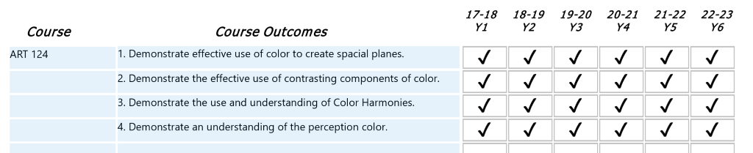
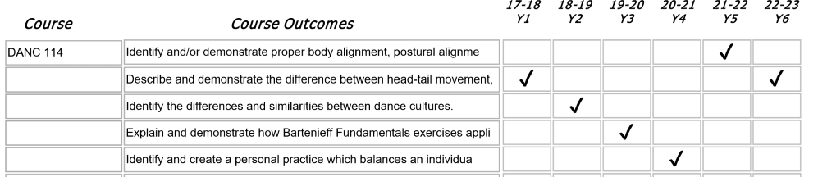
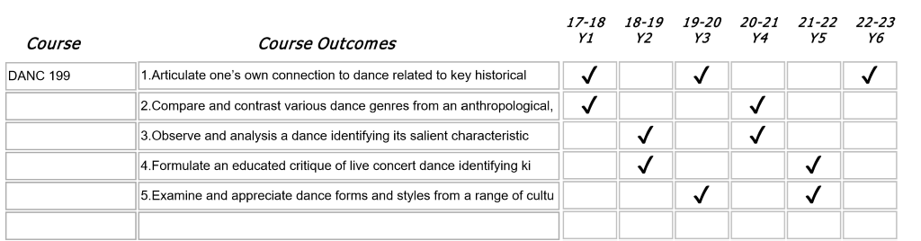

Supplement 2. Tentative Outcomes Training

SUMMER 2020
Thurs. July 23  10:00 AM-11:00 AM | Utilizing Canvas to Gather Outcomes Data | Zoom address
Thurs. July 30  11:00 AM- 12:00 PM | Utilizing Canvas to Gather Outcomes Data | Zoom address
Fri. Aug. 7  10:00 AM-11:00 AM | Utilizing Canvas to Gather Outcomes Data | Zoom address
Thurs. Aug. 13  10:00 AM-11:00 AM | Accessing Outcomes for Syllabus Inclusion | Zoom address

FALL 2020
Week 1  Fri. Aug. 21  12:00 PM- 1:00 PM | Utilizing Canvas to Gather Outcomes Data | Zoom address
Week 2  Fri. Aug. 28  9:00 PM- 10:00 PM | Program Plan: Close-the-Loop | Zoom address
Fri. Aug. 28  11:00 AM- 12:00 PM | Outcomes Committee Member Training | Zoom address
Week 3  Thurs. Sept. 3  4:00 PM- 5:00 PM | Utilizing Canvas to Gather Outcomes Data | Zoom address
Week 4  Thurs. Sept. 10  12:00 PM-1:00 PM | Program Plan: Close-the-Loop | Zoom address
 | Program Plan: Close-the-Loop | Zoom address
Week 5  Weds. Sept. 16  5:00 PM- 6:00 PM | New to Rio: New to Outcomes | Zoom address
Week 6  Fri. Sept. 25  12:00 PM- 1:00 PM | Utilizing Canvas to Gather Outcomes Data | Zoom address
Week 7 | Program Plan: Close-the-Loop | Zoom address
Week 8 | Crafting Quality Course-level Outcomes | Zoom address
Week 9 |  | Zoom address
Week 10 | Utilizing Canvas to Gather Outcomes Data | Zoom address
Week 11 | Program Plan: Close-the-Loop | Zoom address
Week 12 | Summary of Findings (Improving the Narrative) | Zoom address
Week 13 | Reporting Results of Outcomes Assessment | Zoom address
Week 14 | Linking Outcomes Findings to Action Items | Zoom address
Week 15 | Inputting Fall 2020 Measures and Findings data | Zoom address
Week 16  Tues. Dec. 1  4:00 PM- 5:00 PM | Inputting Fall 2020 Measures and Findings data | Zoom address
Wed. Dec. 2  1:00 PM-2:00 PM | Inputting Fall 2020 Measures and Findings data | Zoom address
Thurs. Dec. 3  11:00 AM- 12:00 PM | Inputting Fall 2020 Measures and Findings data | Zoom address

Supplement 3. Institutional Effectiveness Committee Recommendations

1. The Outcomes Committee should provide appropriate training and guidance to instructional programs on the Summary of Findings section of TaskStream so that the narratives describe the results of the outcomes assessment rather than repeating outcomes statements.

2. The Outcomes Committee should provide appropriate training on reporting results of outcomes assessment so that results go beyond whether standards are met and actually report data.

3. The Outcomes Committee should provide appropriate training on the Findings section of the TaskStream template so that the Findings section reflects specific actions and a rationale for those actions. Programs should be able to specify what actions will be implemented as a result of their assessment findings or provide a rationale for no actions taking place as a result of their assessment findings.
4. The Outcomes Committee needs to establish and communicate to all instructional programs the deadline for submitting the Course Outcomes Timeline. Timelines need to be submitted as part of the Annual Program Plan and need to be on file in Task Stream.

5. The Outcomes Committee needs to establish and communicate a protocol or recommendation for small or one person departments to dialogue about course outcomes assessment and record the dialogue and action plan as part of closing the loop.

6. The Outcomes Committee should take the lead in developing examples that demonstrate appropriate use of outcomes data and actionable instructional strategies that can be used to improve student outcomes or to provide a rationale for why an improvement plan is not necessary.

7. The Outcomes Committee should also review the Closing the Loop document and make revisions so that programs can report on whether the actions they took to improve student performance resulted in increased mastery of student learning outcomes in subsequent assessment cycles.

