

Faculty Guidebook
2026-2027

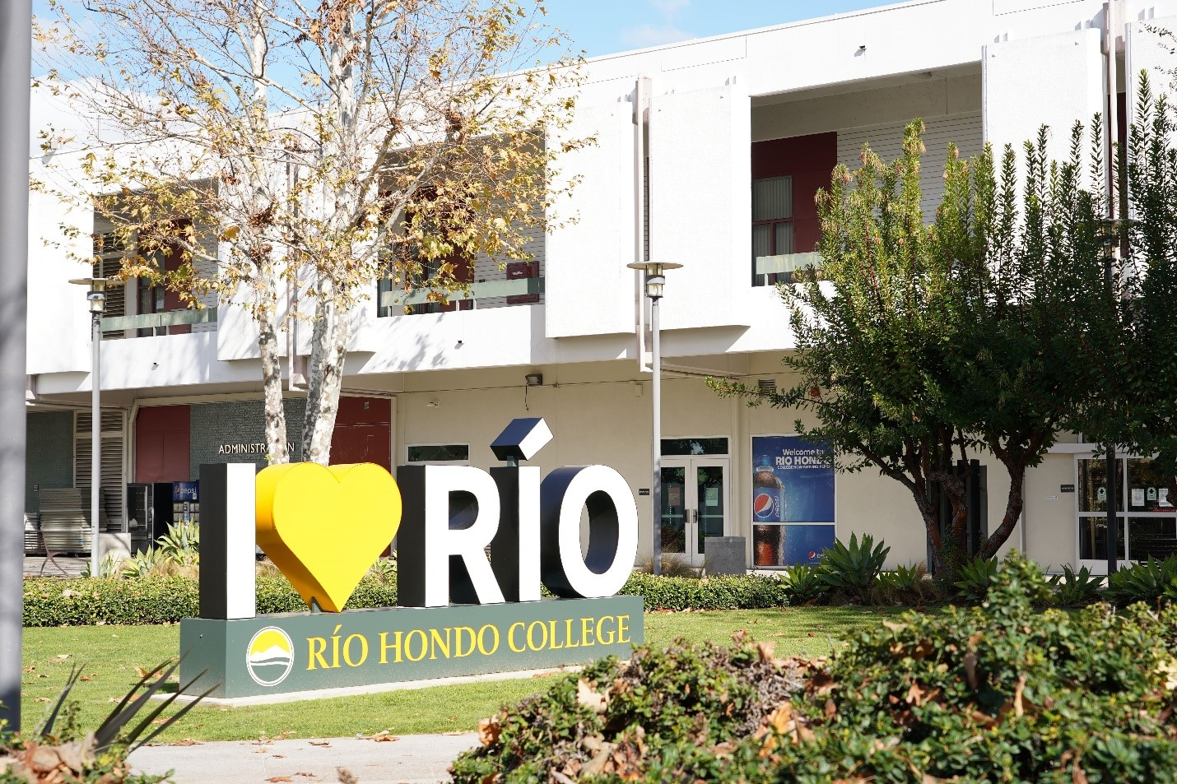
Thank you for your willingness to serve as an instructor in the Honors Transfer Program (HTP). This guidebook is designed to answer many questions you have about the HTP and to provide suggestions for teaching an Honors section. It is also intended to be a dynamic document, so please be sure to let us know if there are suggestions or clarifications needed.

Unique Opportunities for an Honors Instructor:

- The opportunity to work with highly motivated students seeking transfer admission to competitive universities. Based on program review and program planning data, success in honors sections exceed campus benchmarks and non-Honors sections.

- The opportunity to engage in distinct pedagogies from other classes and/or sections being taught. Honors instructors are encouraged to experiment with new ideas and approaches in disseminating course content. Consider the Honors section as a laboratory for your teaching approaches.

- An opportunity to work with students on projects and research papers that could be presented at a research event. More details can be found in this guidebook.

- An opportunity to work with a program that has nearly 100% transfer success. Almost all students that complete the HTP are accepted to numerous universities and ultimately transfer.

Questions or suggestions: Contact Dr. Ea Nicole Madrigal, HTP Coordinator emadrigal@riohondo.edu
Table of Contents
Topic Page

Description, Requirements, and Benefits 4
History and Affiliations 7
Honors Classes/Curriculum 8
Research Opportunities 13
Teaching an Honors Class 15
Appendix A: Approved Honors Classes and Modality 20
Appendix B: Request for Special Arrangement Honors Class 22
Appendix C: Contact Information Honors Transfer Program 24

Rio Hondo College Honors Transfer Program: Description, Requirements, and Benefits
Rio Hondo College's Honors Transfer Program (HTP) is designed to challenge, enrich, and better prepare academically talented and highly motivated community college students seeking transfer to a four-year university.
The HTP provides a structure for initiative-taking students to complete transfer requirements, maximizing their opportunity for transfer admission. Any student who completes ENGL C1000 with a ‘B’ or better or earns a ‘3’ or better on the Advanced Placement (AP) exam in Composition and Language is eligible for the HTP.
After attending an HTP Information Session, students are invited to complete the Program Application and the Program Agreement Form. The following are the requirements for completing the program:
- Maintain a 3.2 or higher GPA in UC-transferable courses.
- Enroll in at least one Honors course per semester.
- Meet with the Honors counselor on a regular basis throughout the semester, at minimum once per semester.
- Attend/participate in one Transfer Workshop or Honors event each semester.
- Complete 5 Honors courses with a grade of “B” or better in all courses (as part of the 60 transferable units)
- Achieve an overall transferable college GPA of at least 3.2—the higher the better to be competitive for selective schools.
- Finish the program requirements by the end of the Spring semester before transfer.
- Complete lower division major preparation requirements along with the Intersegmental General Education Transfer Curriculum (IGETC)

Students are provided with a designated counselor, a faculty coordinator, smaller class sizes, and engaged instructors. Furthermore, active students in the HTP are given priority registration after completing 2 Honors courses with a 'B' average. Upon completion of program requirements, Honors students are recognized in the commencement brochure and receive a certificate of completion and medallion.

Benefits for students in the Honors Transfer Program include:
- Special admission consideration at several partner colleges and universities
- Access to the dedicated Student Lounge (S201)
- An enhancement of students’ transfer applications
- Small, vibrant, and innovative classes
- Early/priority registration
- Access to personalized advising
- Participation in the Faculty-Mentee Program
- Participation as a Student Ambassador
- Individual or group research opportunities
- Philanthropic opportunities
- Community while at Rio Hondo
- Recognition and celebrations
Special admission consideration at several partner colleges and universities:
One of the main reasons that students join the HTP is to have special admission consideration at several 4-year colleges and universities. There are honors transfer agreements between Rio Hondo College (as part of the Honors Transfer Council of California) and several baccalaureate granting institutions. The current list of participating colleges and universities can be found by visiting this website Honors Transfer Council of California | Transfer Partners.
Small, vibrant, and innovative classes:
Stand-alone honors classes are designed to engage Honors students in robust interaction with peers and faculty. Class sizes remain low to facilitate this process. Combined Honors courses provided opportunities for the Honors cohort to engage in distinct activities and assignments.
Early/Priority registration:
Students actively participating in the HTP are provided with a priority registration date upon fulfilling the following program criteria:
- The Honors student has successfully completed two Honors classes.
- The Honors student has met at least once with the designated Honors counselor during the semester.
- The Honors student has participated in at least one Honors recognized activity during the semester.
Access to personalized advising:
Due to the many nuances involved in the transfer process, Honors students can gain valuable insights and information by meeting with the designated Honors Counselor. These communications are so essential that meeting with the Honors Counselor at least once a semester is a requirement of the program. Recognizing the opportunity to connect with the Honors counselor, many students seek advising numerous times during a semester.
To schedule an appointment with the Honors Counselor, students can do one of the following:
- Call the transfer center at 562-692-0941.
- Schedule an appointment through Access Rio
- Visit the Transfer Center in SS 201
Individual or group research opportunities:
Each Honors course is embedded with the opportunity for students to conduct research. Although the specific project and requirements vary by course topic and faculty member, the purpose of the research component is to provide students an assignment that cultivates their intellectual curiosity, provides a means to promote and/or expand on students’ academic interests, and prepares students for the skills necessary when transferring to research colleges and universities.
In addition to completing the research component in each Honors class, students are then invited to share their work at the following events:
- The Honors Transfer Council of California (HTCC) hosts an Honors research conference at a University of California campus.
Showcasing one’s research is an excellent personal growth experience as well as a phenomenal activity to highlight on a transfer application.
Community while at Rio Hondo:
Attending a community college can sometimes feel a bit isolating. Many students are juggling family and work commitments with the demands of being a college student. Through smaller class sizes and participation in Honors activities, students can engage more intentionally with their peers. Likewise, many former Honors students have commented that being with likeminded students is a significant motivator in completing Honors classes and pursuing many transfer options.
Recognition and celebrations:
Each student that successfully completes 5 Honors courses with a ‘B’ average, earns a 3.2 cumulative GPA, and meets all the IGETC or CSU General Education Requirements earns the recognition of Honors Scholar. Honors Scholars are given a medal, certificate of completion, and if graduating, their names are annotated on the commencement booklet as ‘Honors Scholars’.
Along with many other stellar students at Rio Hondo, Honors Scholars are recognized at an event held each spring semester.

Rio Hondo College Honors Transfer Program: History and Affiliations
History of the Program:
The Honors transfer program began in 1997 in coordination with UCLA’S Transfer Alliance Program (TAP) with the goal of providing a transfer pathway for high achieving students. The first courses were offered in 1999.
The program continued to grow by offering more Honors sections and recruiting students. As of Spring of 2024 there are fifty approved Honors classes offered in a variety of modalities including on campus, remote synchronous, hybrid and online. For a complete list of current Honors courses, go to Appendix A. The Rio Hondo Honors Transfer Program has supported hundreds of students in their transfer endeavors to some of the most prestigious universities including UCLA, UC Irvine, and UC Berkely to name a few.
Program Affiliations
More details about the Transfer Alliance Program can be found at: UCLA Transfer Alliance Program | UCLA Undergraduate Admission
Rio Hondo’s HTP Coordinator and Counselor also participate in the Honors Transfer Council of California (HTCC) consortium. The goal of HTCC is to share best practices in offering Honors Programs throughout the state. Another critical goal of the council is to establish transfer agreements between consortium member colleges and 4-year colleges and universities. A comprehensive list of transfer institutions can be found at Honors Transfer Council of California | Transfer Partners

Rio Hondo College Honors Transfer Program: Curriculum and Scheduling Honors Classes
Honors classes at Rio Hondo are submitted through the curriculum process as distinct courses. All Honors courses at Rio Hondo are likely based on a non-Honors section. Any department should consider writing Honors sections for their courses for the following reasons:
- It provides students in the program and those considering the program a wider range of options to select their courses.
- It provides faculty with a unique opportunity to have a smaller class size with motivated students.
- It provides students and faculty to be collaborative and innovating in the teaching and learning process.
Curriculum considerations:
A general guide is that a course should be CSU or UC transferable and meet the IGETC GE requirements. Likewise, lower division major preparation courses are also an appropriate consideration for an Honors class. It is advised to consult with the Honors Coordinator to verify the appropriateness of offering a class as Honors.
The distinction between a non-Honors section and an Honors section is more in-depth writing and reading. The general philosophy is based on transfer partners’ requirements for admission along with pedagogical practices of honors programs in community colleges and universities.
What are the curriculum guidelines for an Honors Course?
Writing an Honors course follows the same general guidelines as any course at Rio Hondo. Consult with the Curriculum committee chair, the curriculum representatives of your division and/or the curriculum website for the latest information on curriculum guidelines. This information is extrapolated from the website and the Curriculum Chair and Committee are the definitive source for all curriculum matters.
Revisions
If there is a non-Honors section and an Honors section of the same course, the past practice of the Curriculum committee is to review any revisions at the same time. In other words, if Philosophy 101 is being revised, the related Honors section should also be revised.
Curriculum and Hybrid/online
The HTP Advisory Committee supports offering both online and hybrid sections of Honors courses. The same curriculum procedures are followed when requesting approval for online and/or hybrid Honors sections.
The following are quick references for creating an Honors class with the associated CurrIQunet Sections:
Course Cover Sheet:
- Course Title: The word ‘Honors’ is to be added at the end of the title for example Introduction to Sociology Honors
- Course Number: 101 H (The letter H is included after the number)
- Course Description: The description will be the same as a non-honors course with the following sentence added to the end: ‘This course is intended for students eligible for the Honors Transfer Program’
- Class size: Honors class sizes are 25 students.
Course Attributes, Cross Listed Courses, General Education: Same as the Non-Honors section
Library Resources: Same as the Non-Honors section but there may be additional resources based on the Honors section.
Requisites: English 101 (ENGL C1000) must be indicated along with any other requisites for the course
Entry Skills: These statements must be included as the entry skills:
• Write a multi-paragraph essay with a thesis statement and the use of outside research
sources to support the thesis.
• Demonstrate through essay writing the relationship between reading different points of
view, and developing an original thesis statement, which can be supported by logical
arguments and researched evidence.
• Use critical thinking processes to clearly and logically explain and/or defend points of
view.
Course Objective/Exit Skills: The same skills from the non-Honors section should be included. Additional exit skills should include that students have gained comprehension and research skills.
Course Content: Same as the non-Honors section
Methods of Instruction: Same as the Non-Honors section; may include additional methods.
Assignments: Same as the non-Honors section with the addition of reading and a project paper, term paper or some type of capstone assignment.
Methods of Evaluation: Same as the non-Honors section with the addition of evaluation of reading and term project.
Student Learning Outcomes: Same as non-honors section.
Textbooks/Instructional Material: Same as non-Honors section but additional materials can be added.
Distance Ed: The approval of Honors courses for Distance Education is the same process as any course at Rio Hondo.

Scheduling and Offering Honors classes:
Once a course has been approved to be offered as an Honors section, the course can be included in the schedule of classes. As with any courses at Rio Hondo and per Rio Hondo policies, the right of assignment of all classes is determined by division Deans. Past practice has been to offer the same honors courses each semester to provide some predictability for students and counselors in executing an effective education plan.
The HTP Coordinator provides a suggested master Honors schedule to all division Deans with courses in their areas. The goal of this approach is to offer Honors students a wide range of options to fulfill the 5 Honors courses while completing their general education and major preparation requirements. Without communication between and among divisions, it is possible that several Honors courses are offered at the same time and day, ultimately minimizing options for students.
Key Points:
- Not all students enrolled in an Honors course are in the Honors Transfer Program. Eligibility for an Honors class is based on a student satisfactorily completing the prerequisite. Some courses may have additional pre-requisites given the skills necessary to be successful in the course.
- No extra grade points or units are awarded for Honors classes.
- Honors courses are typically offered during the fall and spring semester in a 16-week format. A few highly sought after general education courses have been offered during summer with some success.
Types of Honor Classes:
Stand-Alone Honors Classes
This type of offering describes a class in which all students enrolled are seeking Honors credit. Upon mutual agreement between the academic senate and administration, Stand-Alone honors courses are capped at a maximum of 25 students. As with any courses at Rio Hondo, it is at the faculty member’s discretion to add students beyond the course size limit.
The Stand-Alone model is the ideal delivery of an honors course. The smaller class size provides for meaningful and provocative interaction among and between the instructor and students. Also, this type of class cultivates a cohort of like-minded students seeking transfer opportunities to highly competitive universities. However, practical challenges such as low registration and/or fiscal constraints are also considered by a division Dean when determining how an Honors class will be offered in a given semester.
Combined Honors Classes
This type of offering describes a class in which two sections (with distinct CRN’s) meet on the same day and time. For example, a section of Sociology 101 and Sociology 101H are scheduled on T/TH from 9:40-11:05am, meet in the same location, with the same instructor. The overall number of students in total does not exceed the established class size for the non-Honors section. In the above example, the overall class limit is 45 with 34 students enrolled in the non-Honors section and 11 students enrolled in the Honors section.
Given the additional work necessary to facilitate this type of course, the district has agreed to an additional 1.3% increase for a class that is considered combined. All load considerations should be determined in consultation with the division Dean.
Considerations for a combined class:
- Please be sure to remind/notify all students in the Honors section that they are registered in that specific section. Sometimes, students overlook the H or do not understand the distinct section when registering for classes. It is also an opportunity to promote the HTP to students not in the Honors section.
- Two distinct syllabi should be created, one for the Honors section and another for the non-Honors section.
- The content of the course can be exactly the same and there are no expectations that there is distinct lecture material.
- In general, Honors sections include additional reading and additional writing. For example, for all students in a combined class, a general textbook is assigned. Additionally, for students in the Honors section, an instructor can opt to add reading in the form of additional articles, a reader, an additional textbook etc. Likewise, for any assessments, an instructor might give the same exam to all students and include an additional essay or two for students in the Honors section.
- All Honors courses require a project, research paper, or final assignment of some sort. Since it is part of the course outline and is a distinct feature of an Honors course, instructors might consider including language in their syllabus indicating that a passing grade is only earned for Honors with satisfactory completion of the Honors project.
- Although not required, instructors should consider meeting with Honors students in a few ‘outside of class’ sessions. These can take place via Zoom, a discussion board on Canvas or in-person.

Special Arrangement Honors Class
As the name suggests, this course is by special arrangement/permission only. There are circumstances when a student is nearing graduation/transfer, and none of the Honors courses being offered in a particular semester meet their schedule (time restrictions, requirements unfulfilled, etc.) A student can request that an Honors section be added to a non-Honors section. This request can only be made if the course has been approved for Honors though the curriculum process. Upon agreement by the faculty and approval of the appropriate division Dean, a distinct Honors section is added to the non-Honors section. The course is then facilitated like a combined course.
All the process are articulated using the ‘Special Arrangement Form’ Appendix B.

Rio Hondo College Honors Transfer Program: Research Opportunities
Almost all students in the HTP are applying to highly competitive universities. In preparation for their transition to upper division major coursework which will include more research driven assignments, students can showcase their research while at Rio Hondo.

Honors Transfer Council of California’s Annual Research Conference
Spring Semester

One goal of the council is to host an annual research conference for community college Honors students. Many are seeking admission to research-based institutions, the conference is an opportunity to prepare students for research and ultimately to create a community of learners.

This is one of the rare opportunities community college students have to participate in a large-scale research conference and faculty support is instrumental in student participation. In addition to the experience gained from directly participating in a research conference, students are also further able to distinguish themselves when applying to transfer institutions.

The conference is held in the Spring semester and historically, has been hosted by a local University of California campus. It is a day-long event in which students can participate in the following categories: Individual oral presentation, group oral presentation, Individual poster presentation, group poster presentation and performance.

Participation in the conference is regulated by submitting a conference abstract to the HTCC Conference Committee in the Fall preceding the conference, typically in mid-December.

How can Honors Instructors promote this opportunity?

- Model elements of the final research project/paper assigned in the Honors section to the requirements for submitting an abstract proposal for review.

Generally, all the modes of presentation require the four following elements:
- A title describing the research/project (no more than 25 words)
- A brief description of the research/project (no more than 25 words)
- An abstract of the research/project (no more than 250 words)
- A maximum of 5 academic references

If possible, incorporate the elements listed above into each student’s final research project/paper so that the work is essentially completed and already reviewed and evaluated.

- Encourage students to submit their research projects to the conference. Take some class time to describe a research conference, its benefits and perhaps share a personal experience.

- Agree to serve as a student mentor for the conference. As part of the abstract submission process, students are asked to identify a mentor for their research. This basically involves reviewing the elements above with the student prior to submission. Although faculty mentors are encouraged to attend the conference, they are not required to attend should a student’s abstract be accepted.

- If students are hesitant to participate as a presenter, encourage them to volunteer at the conference. This is a meaningful path for students to experience an academic conference without the pressure of a presentation. Student volunteers are typically assigned as facilitators during the oral presentations. Their roles include introducing the presenters and fielding questions from the audience.

- Attend the conference. Experiencing the conference first-hand is an exhilarating and powerful day of professional reinvigoration. To observe hundreds of community college scholars share their research truly exemplifies the spirit of the of the Honors philosophy.

- Serve as a volunteer either as a reader in selecting abstracts, or on the day of the event, scoring poster presentations. This experience provides numerous examples of the depth and range of student proposals. Volunteers are provided with abstracts that align with their professional discipline and expertise.

For up-to-date details, please view the HTCC Conference site
Rio Hondo College Honors Transfer Program: Teaching an Honors class

Students in Honors Class
As mentioned above, not all students registered in an Honors class are officially part of the HTP. Registration in a class and applying to the HTP are two distinct activities. Any student that meets the pre-requisite requirements for an Honors section is permitted to register for an Honors class. It is recommended that faculty reiterate that the course is Honors section, perhaps articulating the unique requirements associated with the course. This is especially useful for a Combined Honors class or Special-Arrangement Honors class.

Who are the students in the Honors Transfer Program at Rio Hondo?
The simple answer is that the HTP is for everyone. Since the program was established over 25 years ago, the philosophy and emphasis of the program is that all interested students should have the opportunity for academic rigor and success. Today, the words diversity, equity and inclusion are used to articulate this perspective as the program continues with this open access approach.

In a recent audit of students completing the HTP approximately 25% of students reflected who one might assume would be an Honors student; a high achieving high school student who was accepted to a 4-year university but opted to attend a community college before transferring. Often, these students completed Advanced Placement or Honors course while in high school. As well, they likely participated as Dual-Enrollment students at Rio Hondo.

Roughly 75% are continuing students that ‘found the program’ during their tenure at Rio Hondo. It is important to note that students in Honors are concurrently part of other specialized programs including Educational Opportunity Programs and Services (EOP&S), Veterans, and Returning Students for example.

Having appropriate expectations of students is critical in creating meaningful assessments and outcome measures. Like with any courses at Rio Hondo, student in Honors courses reflect the same range of diversity. The distinct features of students enrolled in Honors is that they have successfully completed English 101 and they are uniquely motivated to challenge themselves for the additional work of an Honors section. By no means should an instructor assume that students in Honors classes have prior experience with Honors or advanced courses in high school.

As with any course taught at Rio Hondo, attention must be given to the official Course outline of Record (COR). The COR for all classes can be found on CurrIQunet.

Best Practices-Teaching in Honors

There are many documented and researched approaches for effective learning in a community college class including, teaching in Honors. In general, for all types of Honors course delivery, there are collective best practices to enhance the learning and teaching experience. The following represents some ideas to consider when preparing for an Honors class:

According to the National Collegiate Honors Council (NCHC),

“Honors education is characterized by in-class and extracurricular activities that are measurably broader, deeper, or more complex than comparable learning experiences typically found at institutions of higher education. Honors experiences include a distinctive learner-directed environment and philosophy, provide opportunities that are appropriately tailored to fit the institution's culture and mission, and frequently occur within a close community of students and faculty.”

Definition-of-Honors-Education.pdf (nchchonors.org)

Furthermore, the NCHC emphasizes:

- Courses that include an emphasis on inquiry and problem-solving approaches. The research project/paper embedded in all Honors courses is an appropriate assignment to facilitate this pillar of Honors learning.
- Courses that provide space for student agency. Efforts should be made to include students in determining topics, methodology, data collection and significant elements associated with research.
- Opportunities for meaningful interaction between students and faculty.
- Various modalities for collecting and administering assignments.
- Meaningful feedback to students with opportunities for drafts and resubmission of evaluated work.

A detailed course design guideline can be found by going to:
Honors Course Design - National Collegiate Honors Council (site-ym.com)
In a study on teaching engagement in a first-year honors experience at a university (2014), the authors emphasized the effectiveness of engagement activities as correlates to student success. Significant resources can be gleaned from the study despite the varied student population. In particular, the research and engagement practices can be adapted to an Honors course at Rio Hondo.
The activities suggested include:
- Service Learning Projects: Combines course content with community service as is considered a High Impact Practice by the AAUC. For more details and examples, see the link below.
  - Service-Learning - Center for Engaged Learning
- A supplemental reader: Identify a book or extended article of interest to the students. Elicit input from students or offer choices and have students vote on the option.
- Immersion experience: Students participate in a group not familiar to them. Some examples include a religious service of a different faith/belief, a city council meeting or school board meeting, etc.
- Interviews: Given a topic or interest, students conduct focused interviews.
- Secondary Data analysis: Students conduct a literature review about a selected topic.
- Out-of-class learning activities: Faculty cultivate a list of approved on campus- and off campus activities for students to participate in.
Best Practices in Honors Pedagogy: Teaching Innovation and Community Engagement through Design Thinking.. (n.d.) >The Free Library. (2014). Retrieved April 16, 2023 from https://www.thefreelibrary.com/Best+Practices+in+Honors+Pedagogy%3a+Teaching+Innovation+and+Community...-a0631689175
Miller, et al. (2021) focused on perceptions of student engagement in Honors classes. The following represents key findings:

- Importance of faculty engagement: Not only do the assignments and activities matter for students in an Honors course but their research indicates faculty engagement is a key variable with long lasting impacts on the students’ academic experience.

- Honors students reported more positive interactions with faculty teaching Honors than non-honors sections. In particular, students emphasized the use of higher order thinking in Honors classes, greater clarity in teaching skills of faculty and that faculty gave useful and timely feedback.

- Honors faculty more often discussed learning strategies than non-honors faculty: As noted in the study, this may seem atypical give the expectation that Honors possess advanced skills. Nonetheless, this was found to be an important class element for many Honors instructors.

- Collaborative Learning: The study found that Honors faculty were more likely to emphasize collaborative learning between students.

- Faculty engagement: Of all the variables compared, the one with the most impact in learning identified is an instructor’s intentional emphasis on interacting with Honors students.

Miller, A. L., Silberstein, S. M., & BrckaLorenz, A. (2021). Teaching Honors Courses: Perceptions of Engagement from the Faculty Perspective. Journal of Advanced Academics, 32(1), 3-27. https://doi.org/10.1177/1932202X20938021
In addition to the previously list studies, the following links contain useful resources:
Best Practices in Honors Pedagogy: Teaching Innovation and Community Engagement through Design Thinking
Good Practices in Honors Education with Examples to Follow
Best Practices in Two-Year to Four-Year Honors Transfers
Varying Formats for Two-Year-College Honors Seminars

Suggested practices for all Honors classes:
- Demystify the faculty role: To the extent the faculty I comfortable, share experiences with students especially college experiences.
- Provide opportunities for one-on-one or small group dialogue with faculty.
- Build in a student contact in the course syllabus.
- Promote activities and opportunities in the Honors Program.
- Encourage and mentor students to present their Honors Research
- Participate in honors activities including the Honors Advisory Committee.
- Be sure to emphasize that the class is Honors, highlighting the specific distinctions with reading and writing/research components.
- Invite students that are not in the HTP to join since they are already challenging themselves with an Honors class.
- Consider incorporating best practices pedagogy into your teaching and assessment.
- Consider including participation in one Honors Transfer of California annual conference. Incorporating elements of the research process into the semester project will be especially useful. Namely, having students write an abstract as part of their research assignment.
- Review the point distribution for the research component of the class. Can the student still earn a passing grade without completing the final project? This would equate to students earning Honors credit without the benefit of the research component.

Suggested practices for combined Honors classes:

When an instructor has both Honors and non-honors students in the same class, there are effective strategies for delivering a meaningful Honors experience.

- Prepare a distinct syllabus for each section (the Honors section and the non-honors section)
- The syllabus should include details about the additional reading and writing/research requirement for the course.
- In a combined class, students might be unaware that they registered for the Honors section. On the first day, verify with your students that are registered in the Honors section.
- If there is space available, invite students that are not registered in the Honors section to consider adding that section instead and ultimately, to join the HTP.
- Consider strategies for meeting with Honors students individually or as a group:
outside of class time conferences (in person or zoom)
in class small group work
group based research project
in-class presentations

Suggested practices for special arrangement Honors courses or a combined course with a few students in the Honors section:

- Be sure to meet with the Honors students at least once outside of class time. This can be incorporated as an assignment.
- If the student is interested and available, consider having the Honor(s) student serve as a Gateway tutor for the students in the class. Contact the Learning Resource Center several weeks before the start of the term to inquire.
- Connect with other faculty teaching very small numbers of students to share a collective out of class session about preparing a poster presentation or research presentation.
- Be an on-going advocate of the HTP. Encourage students to participate in HTP sponsored events and consider attending as well.

Appendix A
Approved Honors Classes and Modality
Department | Course Number | Course Title | Modality
Accounting | 101H | Financial Accounting Honors | on campus
Accounting | 102H | Managerial Accounting Honors | on campus
Anthropology | 101H | Introduction to Physical Anthropology Honors | on campus and online
Anthropology | 102H | Introduction to Cultural Anthropology Honors | on campus and online
Art | 105H (C1100H) | Survey of Western Art: Prehistory through the Middle Ages Honors | on campus
Art | 106H (C1200H) | Survey of Western Art: Renaissance to Contemporary Honors | on campus
Astronomy | 110H | General Astronomy Honors | on campus
Chicanx Studies | 148H | La Chicana: Mexican American Women in Contemporary Society Honors | on campus
Dance | 179H | Dance History Honors | on campus and online
Dance | 199H | Dance Appreciation Honors | on campus and online
Economics | 101H (C2002H) | Principles of Macroeconomics Honors | on campus and online
Economics | 102H (C2001H) | Principles of Microeconomics Honors | on campus and online
English | 201H (C1001H) | Advanced Composition and Critical Thinking Honors | on campus
History | 143H (C1001H) | History of the United States to 1877 Honors | on campus
History | 144H (C1002H) | History of the United States since 1865 Honors | on campus
History | 159H | US Comparative History of Mexican and Asian Americans & Women Honors | on campus
Humanities | 125H | Introduction to Mexican Culture Honors | on campus
Literature | 102 H (C1002H) | Approaches to Literature Honors | on campus
Literature | 112AH | American Literature through 1865 Honors | on campus
Literature | 112BH | American Literature after 1865 Honors | on campus
Literature | 114H | Children’s and Adolescent Literature Honors | on campus
Literature | 117H | Mexican Literature in Translation Honors | on campus
Literature | 130 H | Women and Literature Honors | on campus and hybrid
Literature | 140H | Introduction to the Novel Honors | on campus
Literature | 141H | Introduction to Poetry Honors | on campus
Literature | 142H | Introduction to Shakespeare Honors | on campus
Literature | 143H | Exploring Authors Honors | on campus
Literature | 144AH | World Literature: Antiquity through the 16th Century Honors | on campus
Literature | 144BH | World Literature: 16th Century after 1785 Honors | on campus
Literature | 145H | Introduction to the Short Story Honors | on campus
Literature | 146AH | British Literature through 1875 Honors | on campus
Literature | 146BH | British Literature after 1785 Honors | on campus
Literature | 147H | Cinema as Literature Honors | on campus
Literature | 148H | Introduction to Dramatic Literature Honors | on campus
Literature | 149H | Introduction to Chicana/Chicano Literature Honors | on campus
Math | 130H | Statistics Honors | on campus
Math | 190H | Calculus Honors | on campus
Philosophy | 101H | Introduction to Philosophy Honors | on campus and online
Philosophy | 110H | Critical Thinking Honors | on campus
Philosophy | 112H | Introduction to Logic Honors | on campus
Philosophy | 128H | Introduction to Political Philosophy Honors Same as Political Science 128 H | on campus and online
Political Science | 110H (C1000H) | Government of the United States Honors | on campus
Political Science | 128H | Introduction to Political Philosophy Same as Philosophy 128 H | on campus and online
Psychology | 101H | Introductory Psychology Honors | on campus
Psychology | 210H (C1000H) | Biological Psychology Honors | on campus
Spanish | 201H | Spanish III Honors | on campus and online
Speech | 100H (C1004H) | Interpersonal Communication Honors | on campus
Speech | 101H | Public Speaking Honors | on campus and hybrid
Sociology | 101H (C1000H) | Introduction to Sociology Honors | on campus and online
Theater | 105H | The History and Development of the Theatre Honors | on campus

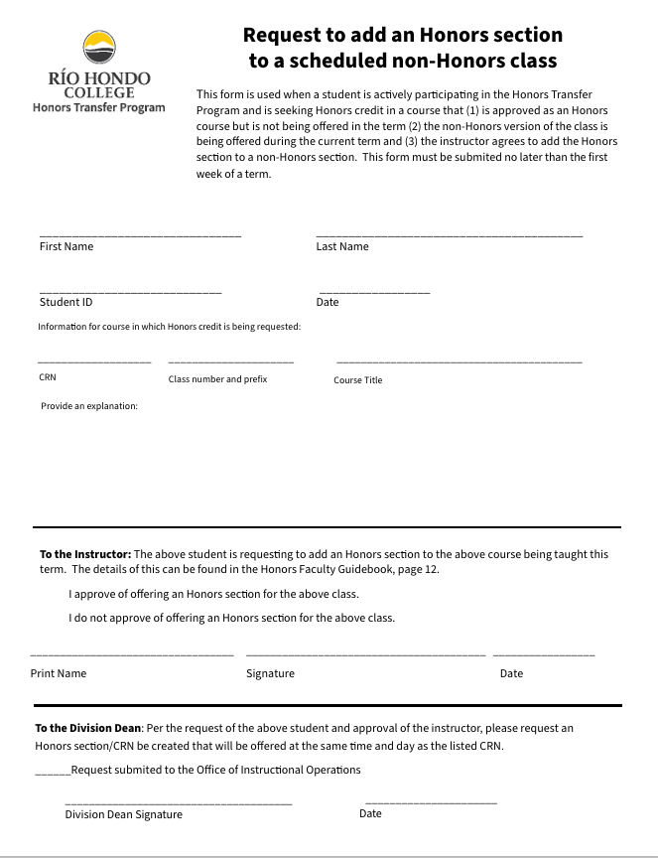
Appendix B


Appendix B1: Procedures for Special Arrangement Honors Class
Request to add an Honors section to a scheduled non-Honors class
Description:
The purpose of this request is to provide students in the Honors Transfer Program (HTP) with the opportunity to take an Honors class in a term when the class is not scheduled. This can occur due to scheduling conflicts, unmet requirements, or other compelling circumstances.
Requirements:
- The student requesting the section is actively participating in the HTP and is in good academic standing.
- The class being requested has been approved as an Honors Course (through the curriculum process) in the approved modality.
- The non-Honors course is being offered in the requested term.
- The instructor agrees to add the Honors section to the non-Honors section.
Process:
- Students requesting this special arrangement will complete the ‘Request to add an Honors section to a scheduled non-Honors class’ form and e-mail it to the Honors Transfer Program Coordinator at emadrigal@riohondo.edu.
- The coordinator will forward the form to the appropriate instructor. If the instructor ‘Approves’ of the arrangement, the instructor will send the form indicating their approval and signature to their Division Dean. If the instructor ‘Does not Approve’ of the special arrangement, they can indicate that on the form and return it to the Honors Coordinator. At that point, the coordinator will inform the student.
- Upon receipt by the Division Dean, they will submit a request to the Office of Instructional Operations to add a distinct Honors section to the existing non-Honors section. The class size of the new Honors section will be determined by the Division Dean. The overall class size will not exceed the approved class size for the course.
- After requesting the additional section be added, the form can be e-mailed back to the Honors Coordinator emadrigal@riohondo.edu.

Appendix C: Honors Transfer Program Contact Information

Name | Position | e-mail | extension
Dr. Ea Madrigal | HTP Coordinator | emadrigal@riohondo.edu | X7573
David Tieu | HTP Counselor | dtieu@riohondo.edu
Christopher Flores | HTP Clerk | cflores@riohondo.edu
Angelica Luviano | HTP Success Coach | aluviano@riohondo.edu
Dr. Adam Wetsman | HTP Dean | awetsman@riohondo.edu

